TheEnterprise User Guide

Key pieces:

- python enterprise.py – This is the main terminal version of TheEnterprise
- python enterprise-flask.py – This is the web app version of TheEnterprise
- celery (redis + rabbitmq) – This does all the heavy lifting (running the tools and parsing)

TheEnterprise was originally developed as a terminal application. However, a GUI was dreamed up and thanks to python Flask, is now a reality. The terminal, enterprise.py, and the web app, enterprise-flask.py, have similar menus and allow you to do the exact same things. Mainly a matter of preference. Fortunately, you don’t have to decide but can use either or both at the same time! In fact starting, python enterprise.py will automatically start enterprise-flask.py if it is not already running, or you can just run python enterprise-flask.py instead.

View Point:

Simply my viewpoint is that this is your data (for your client), so you should be able to have full control over it in whatever form you want. That means that all tool outputs are preserved in their respective output directory (see more in the Tools appendix) with the base directory being setup in the enterprise_user_conf.py file (see the Enterprise_User_Config Appendix).

By keeping all original outputs (and sometimes forcing an output by putting a wrapper around a tool and capturing stdout) you can still do any grep-ing, etc that you want. But now all that data has been parsed and put into a relational database for you as well.

Keeping this same view, I allow you to have complete control over the data in the relational database. You can add, update, or delete any entry. Just remember that this is a true relational database so deleting a Scope entry will delete any Engagement Device associated with it which then in turn deletes any Finding and Ports associated with that Engagement Device (and also all Reconnaissance results for that Scope and Log entries). This is a benefit not a negative, just delete wisely (you are always prompted to confirm the deletion (both in the terminal or web app)).

Limitations:

Kali is the only fully supported and operating system (because some of the tools only were built for Kali). Apart from the OS, your imagination is your only limitation. Use current added tools, add more, etc. Enjoy!

Installation:

The easiest and recommended way to install TheEnterprise is to download the linux_install.sh script from git.

If you do not want it to install to the default location ‘/pentest’ please edit the first two lines (technically line 4 & 5) in the linux_install.sh script so that the line “PENTESTDIR=/pentest” is now “PENTESTDIR=/full/path/to/where/you/want/to/install” and the CLIENTDIR=/usr/local/clients/ is “CLIENTDIR=/full/path/to/where/you/want/engagement-client/data/to/be/saved

To kick of the bash script: First make sure it is executable (chmod +x linux_install.sh), then run: source linux_install.sh. You MUST run it using source.

TheEnterprise install bash script will automatically setup the python virtual environment and install all dependencies appropriately. Follow the onscreen instructions.

At the end of the install.sh script, the install.py script will be called where you then follow the onscreen instructions to setup TheEnterprise (the xx_install.sh script setups up the environment and all dependencies for TheEnterprise). This includes creating a hash key and auto-populating some email events.

If you quit out of the install.py script, you will need to run it manually before using TheEnterprise.

Getting Started:

After installation, you might / probably will need to modify the enterprise_user_conf.py file with values appropriate to your environment and setup. Review the section, “Enterprise User Conf” section for further details.

Now you are ready to rock and roll.

To start TheEnterprise, you will need to:
- ‘cd’ to the installation path (by default this is /pentest/py3virtual/the_enterprise)
- go inside your python virtual environment by typing: source ../bin/activate
- either type: python enterprise.py (terminal version) or python enterprise-flask.py (web app version)
  - enterprise.py automatically will start enterprise-flask.py if it is not already running. That means though, if you quit enterprise.py, you are also quitting enterprise-flask.py.
    - at any time you can manually start up TheEnterprise Web App, enterprise-flask.py by running as indicated in step #3 (still do step #1 & #2 first)
  - To log into the Web App, use the username of whoever started the enterprise-flask.py (if it started as part of enterprise.py then that would be the username of that user)
  - The password is the Hash password that you setup TheEnterprise with (during the install.py process). Below is the login screen you’ll receive:
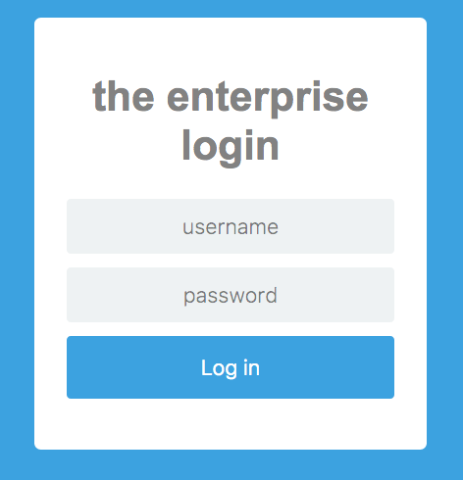

Now you have TheEnterprise running, you need to setup your profile and add your first engagement and setup that engagement (more below).

The remainder of this User Guide is divided into 2 sections: Terminal (enterprise.py) and Web App (enterprise-flask.py) for purposes of screenhots.

Folder Structure:

Your engagement files will all be stored within the base OUTPUT_PATH string designated in enterprise_user_conf.py. From the base OUTPUT_PATH, a folder will be created for each client # plus client name and then within that folder will be the engagement number. This means that if you have the same client with separate engagements, they will be stored within the same client # plus client name folder but separate engagement folders (because the engagement numbers would be different).

For example: if the OUTPUT_PATH was /usr/local/clients/ and the client # was 100-1 and the client name was My Client and the engagement # was 1, then that full path of the engagement would be: /usr/local/clients/100-1__My_Client/1/.

After you have selected (or created) an engagement, the full path of the engagement will be displayed (in the Menu header for the terminal app or in just above (or to the left of) the drop down menu in the web app).

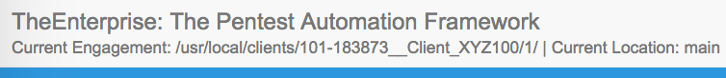

Error Checking:

TheEnterprise (both the enterprise.py and enterprise-flask.py) do input validation. For the terminal you will not be allowed to continue entering data until you enter valid data for a field. For the web app (enterprise-flask.py), you will receive a popup message indicating an invalid entry and will be re-focused back to try again.

Location:

A location can be a physical or virtual location (ex. branch, main street, vlan1, hr dept, etc). Locations are a way for you to divide your results and to break up testing. For instance, if you cannot reach a certain subnet or group of devices but will later be able to, you can still add them to this engagement and just assign them a different location.

Locations also offer a way for you to have multiple people working on the same engagement without conflicting. You can have different people working on different locations.

Tools will only pull from a Scope or Device that is associated with your current location (see below) to run against.

Before you can run any tools, you must have at least 1 location specified. By default, TheEnterprise will create a default ‘main’ location when you create an engagement. You can rename it whenever you want but deleting it would delete everything associated with it and force you to enter a new location before doing anything further in TheEnterprise.

Current Location:

The current location is your current testing location. If you have only created 1 location (only 1 location in the repo), then when you select the engagement to use (or after creating one), the current location will automatically be set for the 1 location.

If you have multiple locations, when you select an engagement, you will be required to select the current location. One of the options will be ‘all locations’ which means it will grab all applicable Scope entries and/or Devices for a specific tool.

You can change your current location at any time Setup -> Current Testing Location.

Before running any tools, an engagement must have at least:
- 1 Client Contact (necessary for email filter testing and the optional email notifications)
- 1 Scope entry (either a website, domain or IP)
- 1 Location (when you create an engagement the location ‘main’ is automatically added)

Scope

The scope includes IP addresses, websites, and domains. You must designate if you have permission to test each entry you make. Any entries that are not designated as permissible will not be included in any tools.

A domain can be a valid, external DNS registered domain or an internal AD domain. Valid, external registered domains will automatically pull the registration information for that domain from DNS.

A website entry, if it contains a valid, registered external DNS domain, will also pull DNS information automatically.

Geolocation is attempted for all Public IPs, registered external domains, and externally accessible websites (not intranet sites).

IP addresses can be entered in CIDR notation (10.1.1.0/24), range notation (10.1.1.0-5), or as a single IP. All IPs when entered will be converted to CIDR notation. This means if you enter a range (10.1.1.0-5), you will not get 1 Scope entry but will have the following Scope entries: 10.1.1.0/30 and 10.1.1.4/31. IPv4 & IPv6 addresses are supported.

If the Engagement is specified as ‘Public Only’ than private IP addresses will not be allowed. For Public IPs, TheEnterprise will try to auto-discover an open IP and open port. This open IP / open port combo is used to ensure you have not been blacklisted or are being blocked when running a tool. This blacklist checking is run before and after each tool. If the blacklist check fails before the tool runs, then the tool will not run and assuming that you have been blocked.

If the tool runs but then after running the open IP / open Port is no longer reachable, most likely you have been blocked and the tool results will be considered invalid since at some point during the tool you were blocked. Results will still be attempted to be parsed, but that Scope entry for that tool will not be considered already run (since it was a failure). See the Rerun Tool Section below for more information on running re-running tools.

An open IP / open Port entry is optional and without a valid entry, no blacklist checking will be performed. You can add or remove the Open IP / Open port entry at any time for any Scope entry by going to Setup -> Scope.

Blacklist Checking

See the Scope section above.

Geolocation

See the Scope section above.

Rerun Tool

An engagement can be specified to rerun tools or not. By specifying that a tool can be rerun, then you can run a tool as many times against the same Scope entry that you want.

If you specify for the engagement to not rerun tools, then you can only run the same tool per each Scope entry 1 successful time. The keyword being ‘successful’. If a tool runs but fails, it is not considered successful and will let you rerun that tool. You can override this behavior by modifying the Log entry for a specific tool / Scope entry and specify to not rerun.

You can change the engagement rerun status at any time under Setup -> Engagement and therefore control which tools to rerun etc.

See the Scope section for additional information on how this is used with a Scope’s open IP / open port entry.

Email Notification

TheEnterprise is capable of automatically sending email notifications to you, the ‘tester’, any number of your colleagues (corporate contacts), and any number of client contacts. Email notifications are triggered when a tool is run and when it has finished. A separate Email Event needs to be created for each action (start or end) to email on both.

Notifications can be turned off globally for each of the 3 types: tester (you), corporate contact (your colleagues), and client contacts in Setup -> Engagement. Corporate contacts and client contacts can be designated individually if that contact should receive the notification.

Here is how an email event works.
- When to send: either start or end
  - Start = when a tool is started
  - End = when a tool has completed
- Event = Tool
- Email Subject -> the subject the email will have (same for all notifications)
- Tester Msg -> the message body for the email to you, the tester
- Corp Msg -> the message body for your colleagues (manager, etc)
- Client Msg -> the message body for your client contacts
If a Msg (Tester, Corp, or Client) is blank then no email notification will be sent to that person or group of people.

You can add, edit, or delete email event notifications at any time using Setup -> Auto Email Event. HOWEVER, modifying here modifies for ALL engagements! So do so carefully and use either generic wording or one or more special PLACEHOLDER designations below.

PLACEHOLDER

A PLACEHOLDER is special text that will be automatically replaced making the otherwise generic message client, target and/or service specific. All caps is required to be a placeholder and the list below are the only ones that are currently supported. Some PLACEHOLDERS are specific to a tool and would not make sense (or replace) with other tools.

Placeholder designations:
- CLIENTNAME -> the current engagement’s client name
- DOMAINNAME -> the current domain (pulled from the Scope) that is being targeted
- EMAIL_ADDRESS -> your profile email address
- EMAIL_MSG_WHERE_TO_FORWARD_BACK_TO -> an email address where messages should be forwarded back (pulled from enterprise_user_conf.py – see Appendix B for additional information)
- ENGAGEMENT -> the current engagement number
- SCENARIONAME -> the email phishing scenario currently selected
- SERVICE -> the current service being targeted (such as SNMP, HTTP, etc)
- START_DATE -> the current engagement’s start date
- TARGET -> current scope entry (or device) being used
- TOOLNAME -> current tool being used

You can also import auto email events from another email_event.db file. For instance, if your manager wants to take care of all the wording for you and your colleagues, they can modify their Auto email events and then just have to send you the modified email_event.db file for you to import. Importing will remove any current email events so do so carefully. This way you can keep the wording between multiple TheEnterprise installs identical.

Tester IP:

You should specify all the IPs used by your testing devices. All results will check to see if the device is a testing device, if so it will not add the result (Device, Open Port, Finding, etc) otherwise it will add it. So to keep your devices out of the results, add them here!

Terminal (enterprise.py)

Setting up your Profile:

Your TheEnterprise profile is stored in ~/.enterprise.profile. You should not manually edit this file but use TheEnterprise to change any values.

If your profile does not exist, you will automatically be asked the questions that make up your profile.
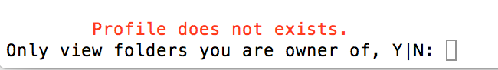

If your profile already exists, you will be asked if you want to change it Y|N.

Creating an Engagement:

You can create a Client/Engagement at any time. In the terminal view – when first starting enterprise.py, type 1 for Create New Client/Engagement.
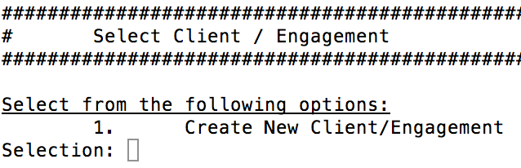

You will then be asked to either select an existing Client or create a new one.

Setting up an Engagement:

After creating and Engagement, you must add at least one Scope entry and at least one Location. Creating the Engagement automatically creates a Location, ‘main’ so you just need to add the Scope entry(ies). If you want to have multiple locations, you should enter those before the Scope entries as you will need to specify the Location of each Scope entry.

In the Terminal App (enterprise.py), you will not be able to get out of the Setup Menu unless you have at least 1 Scope entry and 1 Location.

Web App (enterprise-flask.py)

Creating an Engagement:

In the Web App view, click on the “Create New Client/Engagement” button. You can create a new Client/Engagement at any time by clicking on the left-side vertical link which displays the box below.
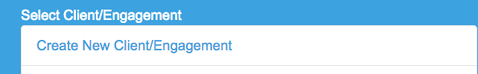

You will then be presented with a form to fill out the necessary fields
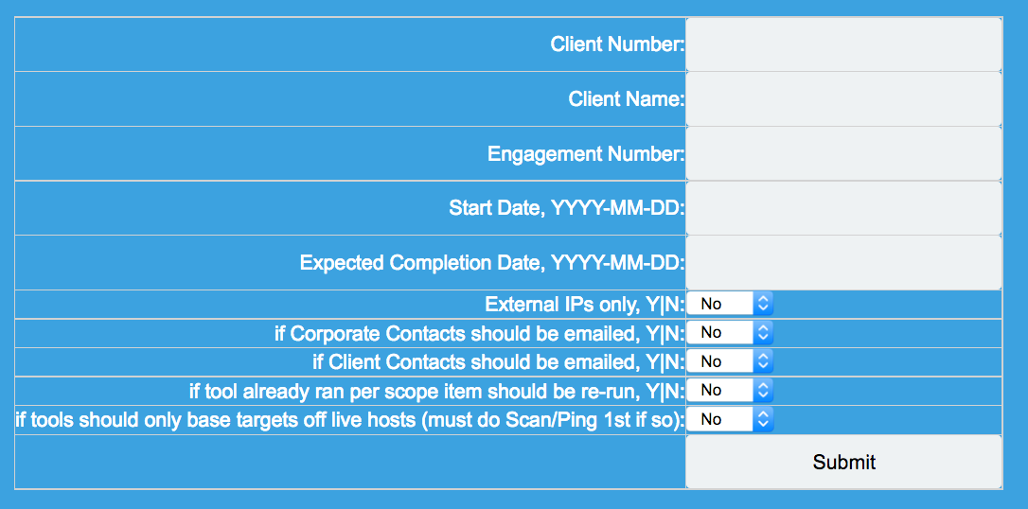

If you try to click away from a required field or enter invalid data, you will receive a warning message and the field will be cleared.

Appendix A: Tools

- Include available PLACEHOLDER
msfrpc - metasploit’s MSFRPCD (installing Metasploit will automatically give you this tool)

Appendix B: enterprise_user_conf.py variables

Some of these variables MUST be changed in order for certain tools to run or even for TheEnterprise to run (such as the ‘LINUX_GROUP’). Renaming variables or deleting variables will keep a specific tool(s) from working and / or could keep TheEnterprise from working. You should only need to change most, if not all, of these 1 time.

Variable Name | Type | Tool | Description
AUTO_START_CELERY | Boolean | TheEnterprise | Used to tell TheEnterprise if it should automatically start CELERY or if it should be manually started.  True = auto start  False = manual
AUTO_START_GUI | Boolean | TheEnterprise | Used to tell enterprise.py (Terminal version) if it should automatically start up the Web App (enterprise-flask.py).  True = auto start  False = have to manually start
OUTPUT_PATH | String | TheEnterprise | Location where all your client engagements will be stored. Required for TheEnterprise to work and MUST be an absolute path not a relative path.
FLASK_KEY | String | Web App – TheEnterprise (enterprise-flask.py) | A unique key that should be kept secret has it is used to secure Web App communications through Flask. You SHOULD change this variable before using TheEnterprise.
FLASK_PORT | Int | Web App – TheEnterprise (enterprise-flask.py) | The port number the Web App (enterprise-flask.py) will be listening on. The default is 1820. This can be any available, open TCP port on your device if you want to change it.
DEVICE_IP | String | Web App – TheEnterprise (enterprise-flask.py) | IP address that the Web App (enterprise-flask.py) will be listening on.  127.0.0.1 = only local connection  0.0.0.0 = any IP address your device has (so if it is in 2 subnets both are accessible – this is NOT recommended). IPv4 or IPv6 are accessible.
EMAIL_ADDRESS | String | TheEnterprise | This is the email address the automatic email events will originate from (SMTP FROM). Required for email notification.
EMAIL_SERVER | String | TheEnterprise | This is the email server to use to send out the automatic email events. Required for email notification.
LINUX_GROUP | String | TheEnterprise | The name of the group (Operating System group) that all created folders and files will be given persmission to.
CELERY_CONSOLE | String | Not Currently Implemented | Possibly might allow for trying to auto start CELERY in a new console tab or within a new screen view sometime in the future.
PYTHONv2_PATH | String | Responder & EyeWitness | Must be the absolute path (not relative path) to where python 2.7 is installed for the tools that need python 2.7. The default location should work in most scenarios (‘/usr/bin/python2.7').
INTERFACE_NAME | String | Responder & Scapy | Used to identify your interface you want to use for the tool(s). If you do not enter it here, you will be forced to select your interface before you are allowed to run this / these tool(s).  Ex: en0
YOUR_IP_ADDRESS | String | Responder & Scapy | Similar to INTERFACE_NAME but is the IP address of the interface you selected in INTERFACE_NAME. Do not mis-match interfaces and IPs or else the tool will not work. If you leave this blank, you will be required to enter the IP to use before running the tool.
SHODAN_API_KEY | String | Shodan | A valid Shodan API key so that Shodan searches can be performed.
BING_API_KEY | String | theHarvester – Bing | Not required but can lead to better search results.
GOOGLE_CSE_API_KEY | String | theHarvester – GoogleCSE | Required to successfully query GoogleCSE (this is different than the standard Google query).
TESTERS_DOMAIN | String | Email Filter | Your valid, registered DNS domain name. (Ex. contoso.com)
PUBLIC_IP | String | Email Filter | The public, external IP address that will be used during the HELO and will appear within the SMTP’s resultant header.
SMTP_EHLO_SERVER | String | Email Filter | Similar to PUBLIC_IP.
EMAIL_RELAY_SERVERS_TO_BOUNCE_EMAILS_FROM | List | Email Filter | A List of String values where each string is an email server that you are authorized to send emails through. (Might be the same as SMTP_EHLO_SERVER.)
INVALID_USER_NAME | String | Email Filter | A username that is highly unlikely to exist on a client’s network. Ex. ThisIsJustATestofTheEmergency
SPOOF_DOMAIN_NO_SPF_DMARC_DKIM | String

Appendix C: Generic tool PLACEHOLDERs (developers use only)

ENTRY – individual target or scope (same as Log.target)
PORT – port of individual ENTRY (pulled from repo or from URL for websites)
SSL – if present will ‘use’ SSL (for nikto will put –ssl in command)
OUTPUT_FOLDER – the client_engagement output directory
SCOPE_ID – scope ID of current ENTRY
FORMATTED_ENTRY – ENTRY that is formatted such that non-alphanumeric characters (plus: -_) are substituted for.
FORMATTED_WEBSITE – ENTRY that is a website but formatted to remove ‘:’ and ‘/’ characters
PROTOCOL – either HTTP or HTTPS (determined by the ENTRY’s URL)

